**2a) Course Name: Angular JS**

*import* { Component } *from* '@angular/core';

@Component({

  selector: 'app-root',

  templateUrl: './app.component.html',

  styleUrl: './app.component.css'

})

*export* class AppComponent {

  isAuthenticated!: boolean;

  submitted = false;

  userName!: string;

  onSubmit(*name*: string, *password*: string) {

    this.submitted = true;

    this.userName = *name*;

*if*(*name* === 'admin' && *password* === 'admin')

    {

      this.isAuthenticated = true;

    }

*else*

    {

      this.isAuthenticated = false;

    }

  }

}

<div *ngIf="!submitted">

  <form>

    <label>User Name</label>

    <input type="text" #username><br><br>

    <label for="password">Password</label>

    <input type="password" name="password" #password><br><br>

  </form>

  <button (click)="onSubmit(username.value, password.value)">Login</button>

</div>

<div *ngIf="submitted">

  <div *ngIf="isAuthenticated; *else* failureMsg">

    <h4>Welcome {{ userName }}</h4>

  </div>

  <ng-template #failureMsg>

    <h4>Invalid Login!!! Please try again...</h4>

  </ng-template>

  <button type="button" (click)="submitted = false">Back</button>

</div>

<!doctype html>

<html lang="en">

<head>

  <meta charset="utf-8">

  <title>MyApp</title>

  <base href="/">

  <meta name="viewport" content="width=device-width, initial-scale=1">

  <link rel="icon" type="image/x-icon" href="favicon.ico">

</head>

<body>

  <app-root></app-root>

</body>

</html>

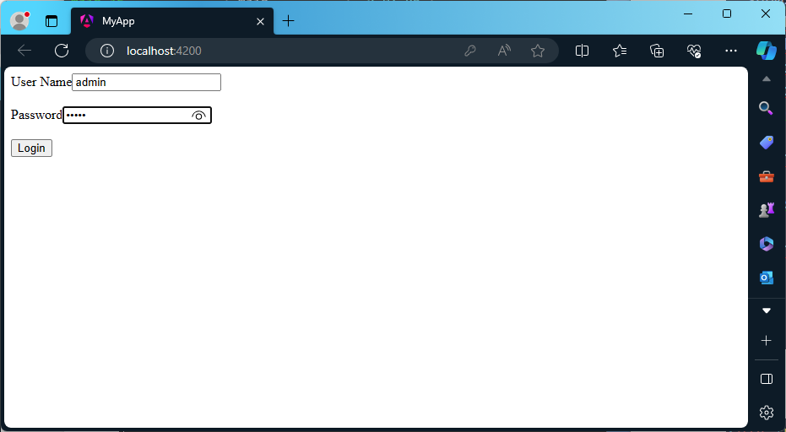

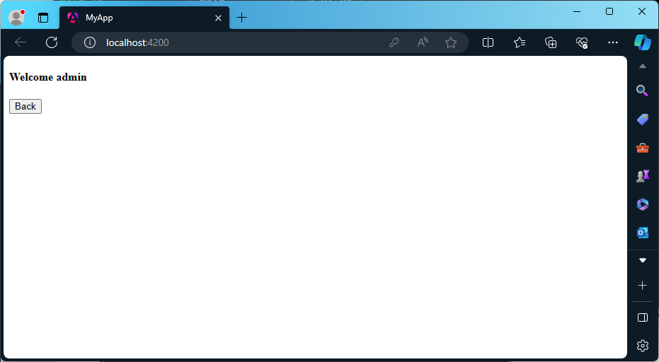

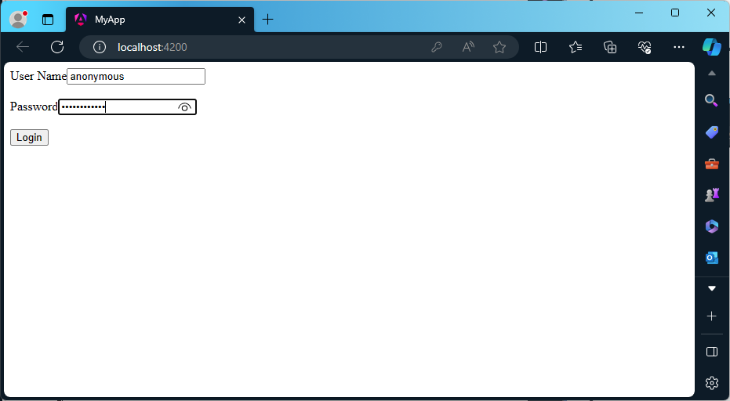

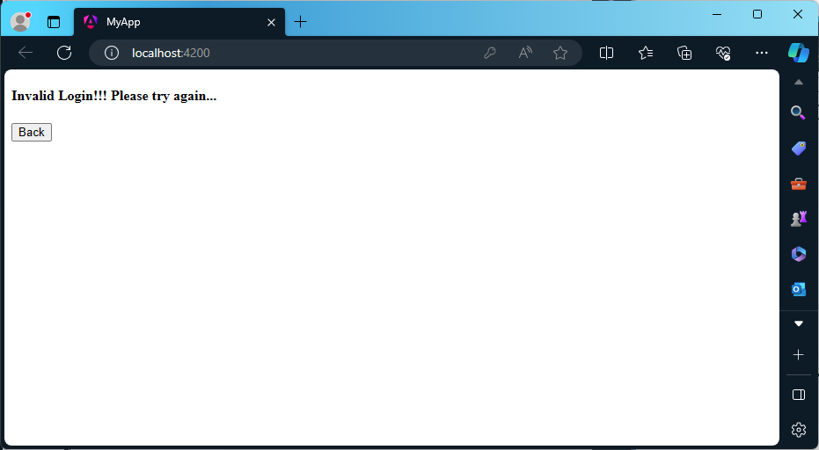

**2b) Module Name: ngFor**

*import* { Component } *from* '@angular/core';

@Component({

  selector: 'app-root',

  templateUrl: './app.component.html',

  styleUrls: ['./app.component.css']

})

*export* class AppComponent {

  courses: any[] = [

    { id: 1, name: 'TypeScript' },

    { id: 2, name: 'Angular' },

    { id: 3, name: 'Node JS' },

    { id: 4, name: 'TypeScript' }

  ];

}

<ul>

  <li *ngFor="let course of courses; let i = index">

    {{ i }} - {{ course.name }}

  </li>

</ul>

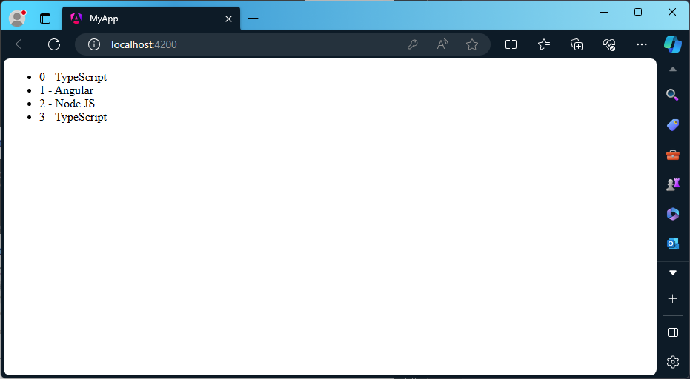

**2c) Module Name: ngSwitch**

*import* { Component } *from* '@angular/core';

@Component({

  selector: 'app-root',

  templateUrl: './app.component.html',

  styleUrls: ['./app.component.css']

})

*export* class AppComponent {

  choice = 0;

  nextChoice() {

    this.choice++;

  }

}

<h4>

  Current choice is {{ choice }}

</h4>

<div [ngSwitch]="choice">

  <p *ngSwitchCase="1">First Choice</p>

  <p *ngSwitchCase="2">Second Choice</p>

  <p *ngSwitchCase="3">Third Choice</p>

  <p *ngSwitchCase="2">Second Choice Again</p>

  <p *ngSwitchDefault>Default Choice</p>

</div>

<div>

  <button (click)="nextChoice()">

    Next Choice

  </button>

</div>

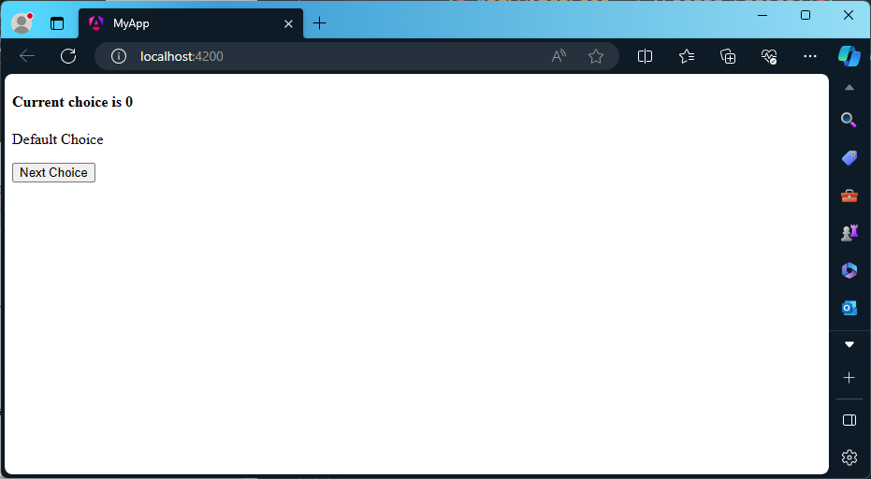

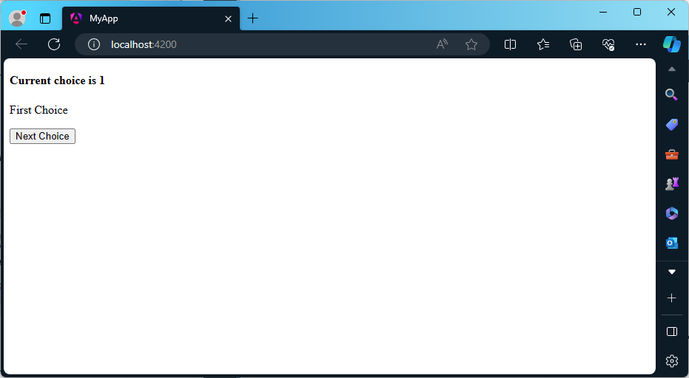

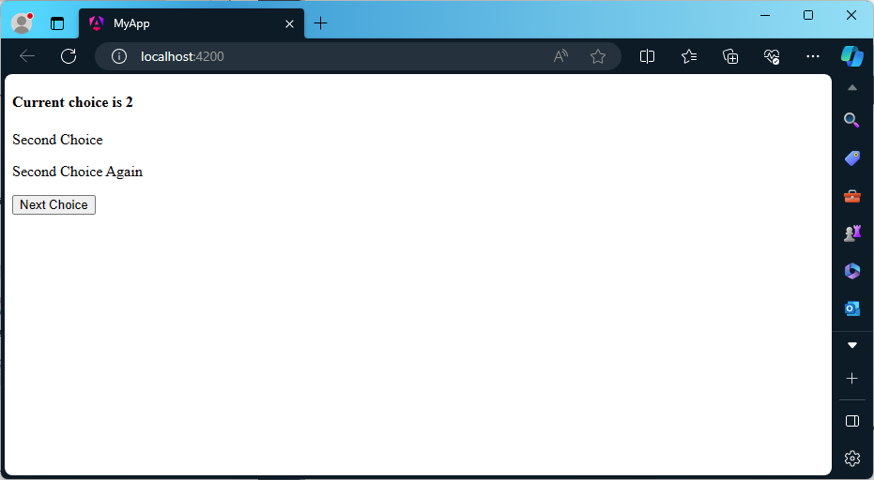

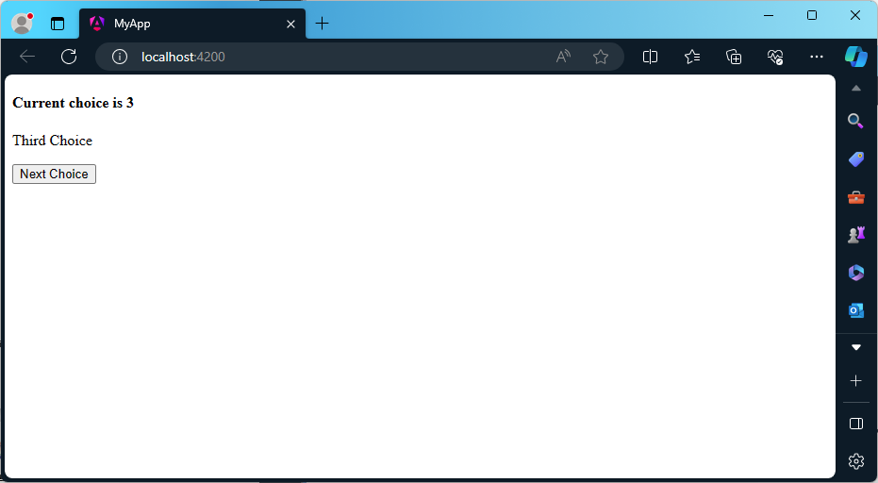

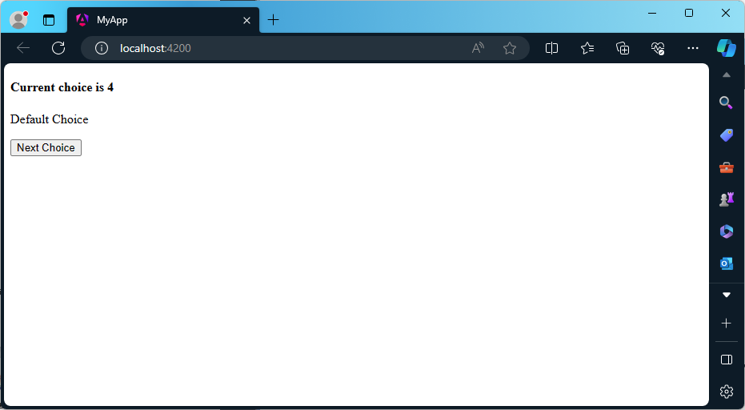

**2d) Module Name: Custom Structural Directive**

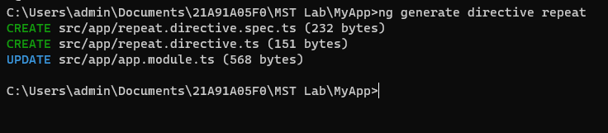

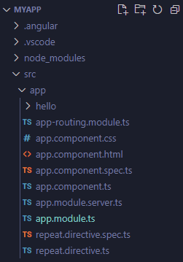

*import* { NgModule } *from* '@angular/core';

*import* { BrowserModule } *from* '@angular/platform-browser';

*import* { AppRoutingModule } *from* './app-routing.module';

*import* { AppComponent } *from* './app.component';

*import* { RepeatDirective } *from* './repeat.directive';

@NgModule({

  declarations: [

    AppComponent,

    RepeatDirective

  ],

  imports: [

    BrowserModule,

    AppRoutingModule

  ],

  providers: [],

  bootstrap: [AppComponent]

})

*export* class AppModule { }

*import* { Directive, Input, TemplateRef, ViewContainerRef } *from* '@angular/core';

@Directive({

  selector: '[appRepeat]'

})

*export* class RepeatDirective {

  constructor(private *templateRef*: TemplateRef<any>, private *viewContainer*: ViewContainerRef) { }

  @Input() set appRepeat(*count*: number) {

*for*(let i = 0; i < *count*; i++) {

      this.viewContainer.createEmbeddedView(this.templateRef);

    }

  }

}

<h1>Custom Structural Directives:</h1>

<h2 *appRepeat="10">Angular JS is javascript front-end framework.</h2>

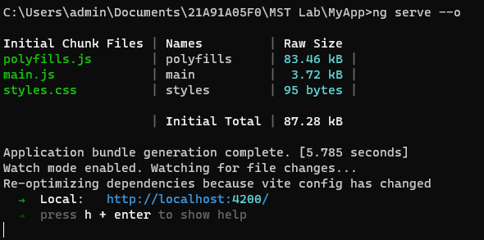

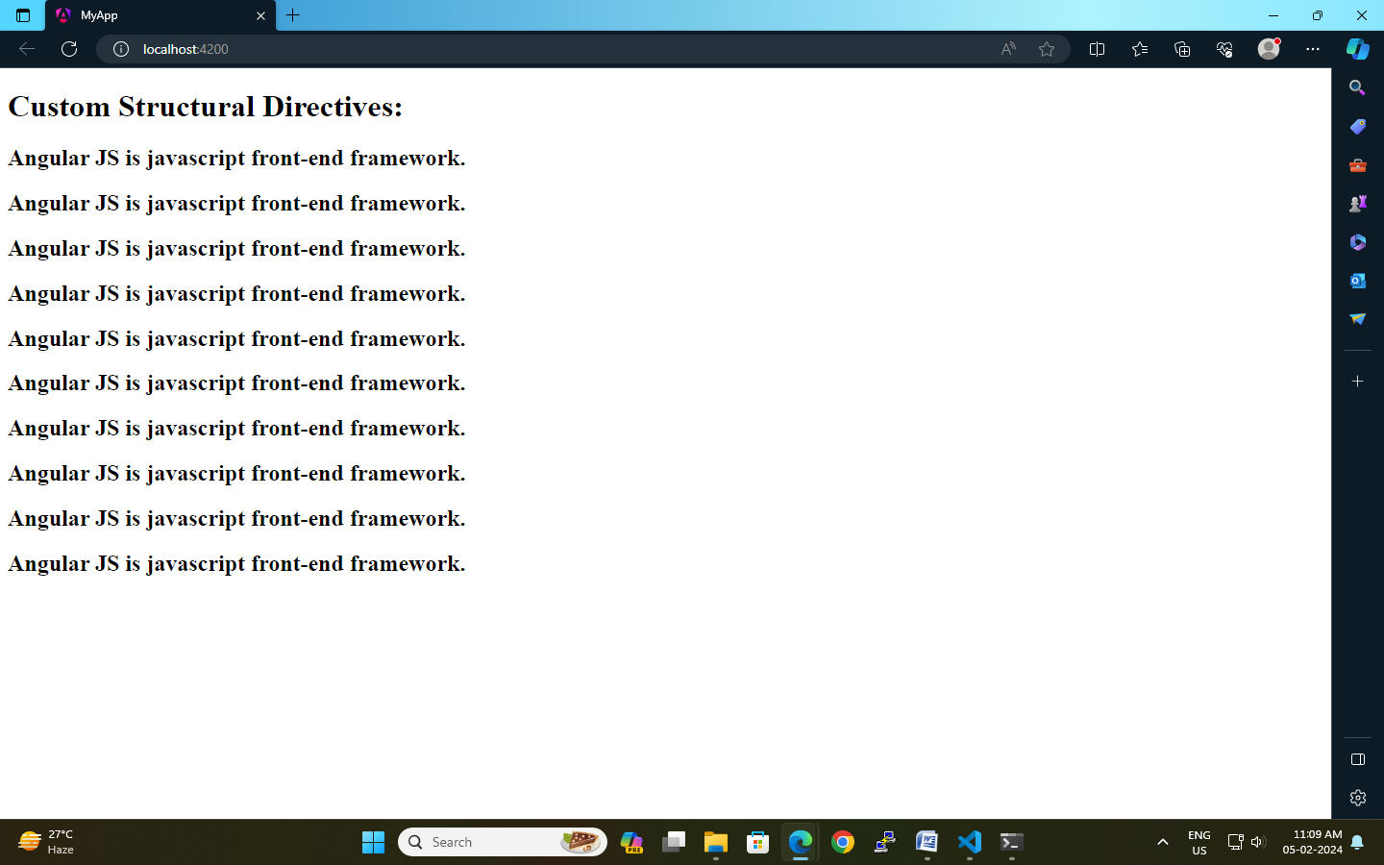

**3a) Module Name: Attribute Directives - ngStyle**

*import* { Component } *from* '@angular/core';

@Component({

  selector: 'app-root',

  templateUrl: './app.component.html',

  styleUrls: ['./app.component.css']

})

*export* class AppComponent {

  title = 'attribute_directives';

  textColor = "green";

  fontWeight = "solid";

  borderStyle = "solid 2px #ffaa00";

  textAlignment = "center";

  fontSize = "20px";

}

<p [ngStyle]="{color:textColor,borderBottom:borderStyle,'font-weight':fontWeight,'text-align':textAlignment,'font-size':fontSize}">Attribute Directives</p>

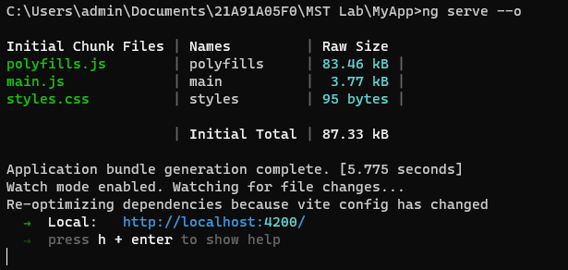

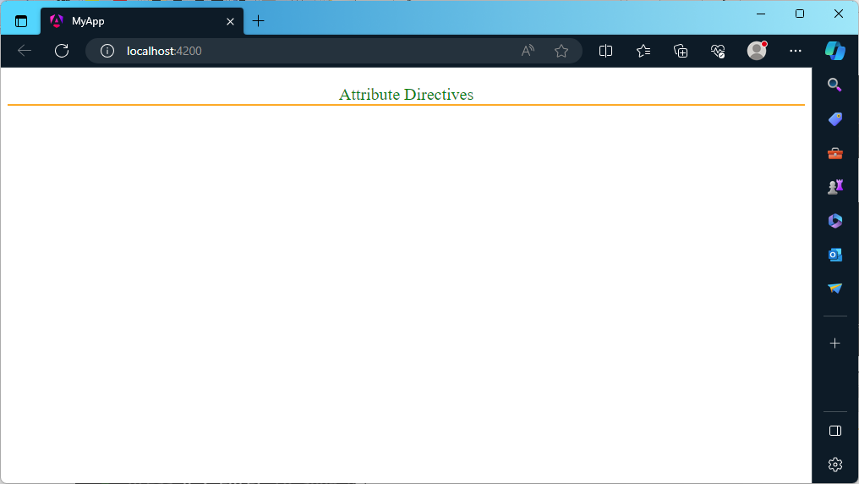

**3b) Module Name: ngClass**

*import* { Component } *from* '@angular/core';

@Component({

  selector: 'app-ngclass',

  templateUrl: './ngclass.component.html',

  styleUrls: ['./ngclass.component.css']

})

*export* class NgclassComponent {

  isBordered=true;

}

<h1>Attribute Directive:ngClass</h1>

<h2 [ngClass]="{bordered:isBordered}">Border{{ isBordered ? "ON" : "OFF"}}</h2>

.bordered {

    border: 1px dashed purple;

    background-color: rgb(255, 153, 0);

}

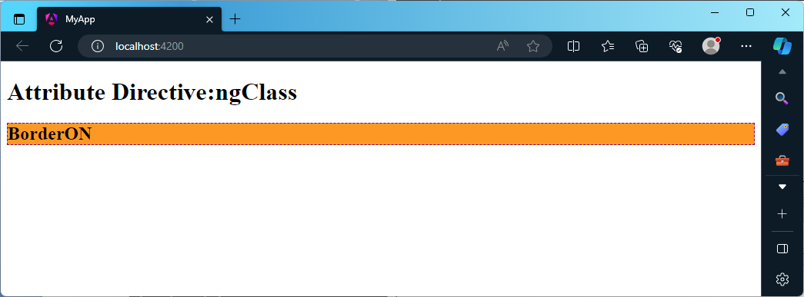

**3c) Module Name: Custom Attribute Directive**

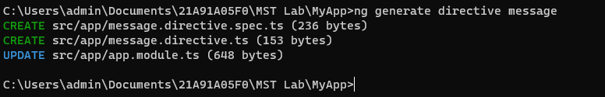

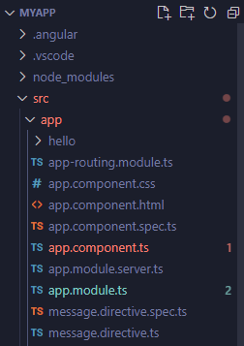

*import* { NgModule } *from* '@angular/core';

*import* { BrowserModule } *from* '@angular/platform-browser';

*import* { AppRoutingModule } *from* './app-routing.module';

*import* { AppComponent } *from* './app.component';

*import* { HelloComponent } *from* './hello/hello.component';

*import* { RepeatDirective } *from* './repeat.directive';

*import* { MessageDirective } *from* './message.directive';

@NgModule({

  declarations: [

    AppComponent,

    HelloComponent,

    RepeatDirective,

    MessageDirective

  ],

  imports: [

    BrowserModule,

    AppRoutingModule

  ],

  providers: [],

  bootstrap: [AppComponent]

})

*export* class AppModule { }

*import* { Directive, ElementRef, HostListener, Input, Renderer2 } *from* '@angular/core';

@Directive({

  selector: '[appMessage]'

})

*export* class MessageDirective {

  @Input('appMessage') message!: string;

  constructor(private *el*: ElementRef, private *renderer*: Renderer2) {

*renderer*.setStyle(*el*.nativeElement, 'cursor', 'pointer');

   }

   @HostListener('click') onClick() {

    this.el.nativeElement.innerHTML = this.message;

    this.renderer.setStyle(this.el.nativeElement, 'color', 'red');

   }

}

<h3>Attribute Directive</h3>

<p [appMessage]="myMessage">Click Here</p>

*import* { Component } *from* '@angular/core';

@Component({

  selector: 'app-root',

  templateUrl: './app.component.html',

  styleUrls: ['./app.component.css']

})

*export* class AppComponent {

  myMessage = "Hello, It is my first custom attribute directive named message."

}

h3 {

    color: #369;

    font-family: Arial, Helvetica, sans-serif;

    font-size: 250%;

}

p {

    color: #ff0080;

    font-family: Arial, Helvetica, sans-serif;

    font-size: 150%;

}

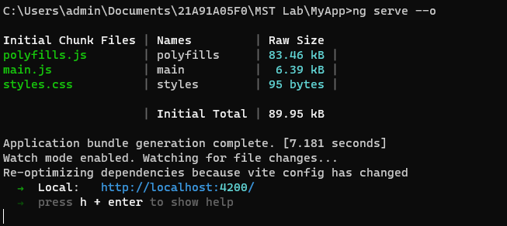

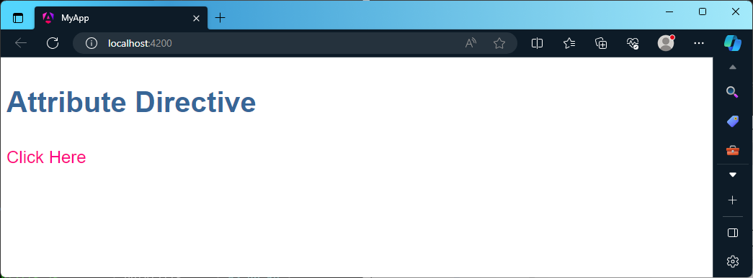

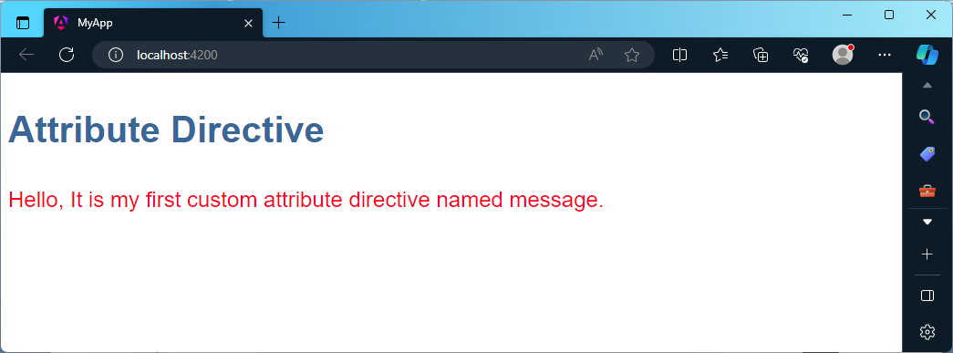

**4a) Module Name: Property Binding**

*import* { Component } *from* '@angular/core';

@Component({

  selector: 'app-root',

  templateUrl: './app.component.html',

  styleUrls: ['./app.component.css']

})

*export* class AppComponent {

  title = 'PropertyBinding';

  imgUrl : string="assets/imgs/misko_hevery.jfif";

}

<h2>Property Binding:</h2>

<img [src]="imgUrl" height="250px" width="550px" alt="Gurez Valley, J&K, India"/>

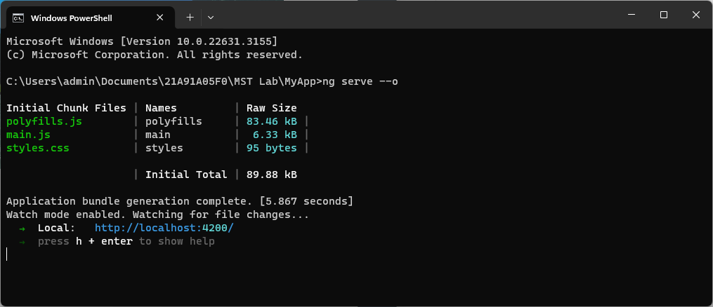

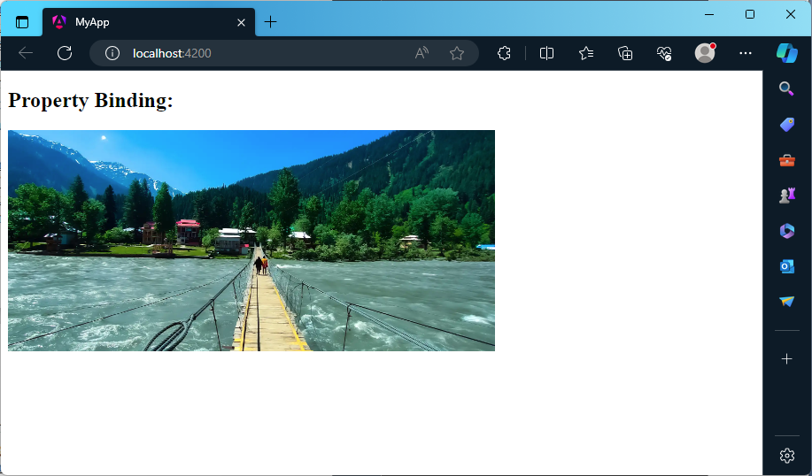

**4b) Module Name: Attribute Binding**

*import* { Component } *from* '@angular/core';

@Component({

  selector: 'app-root',

  templateUrl: './app.component.html',

  styleUrls: ['./app.component.css']

})

*export* class AppComponent {

  title = 'AttributeBinding';

  colspanValue="2";

}

<h2>Attribute Binding:</h2>

<table border="1">

    <tr>

        <td [attr.colspan]="colspanValue">First</td>

        <td>Second</td>

    </tr>

    <tr>

        <td>Third</td>

        <td>Fourth</td>

        <td>Fifth</td>

    </tr>

</table>

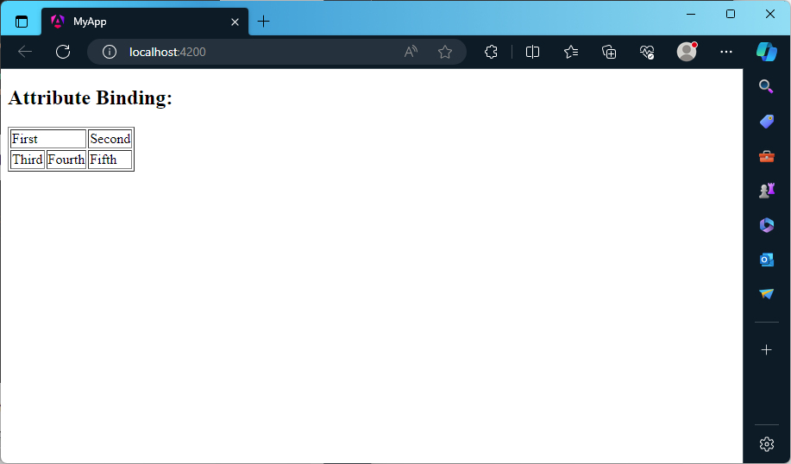

**4c) Module Name: Style and Event Binding**

**Style Binding:**

*import* { Component } *from* '@angular/core';

@Component({

  selector: 'app-root',

  templateUrl: './app.component.html',

  styleUrls: ['./app.component.css']

})

*export* class AppComponent {

  title = 'StyleBinding';

  isValid = "blue";

  isValid1 = '13';

}

<h2>Style Binding:</h2>

<button [style.color]=" isValid ? 'blue' : 'red' ">Hello</button><br/><br/>

<button [style.font-size.px]=" isValid1 ? 13 : 26 ">Hi</button>

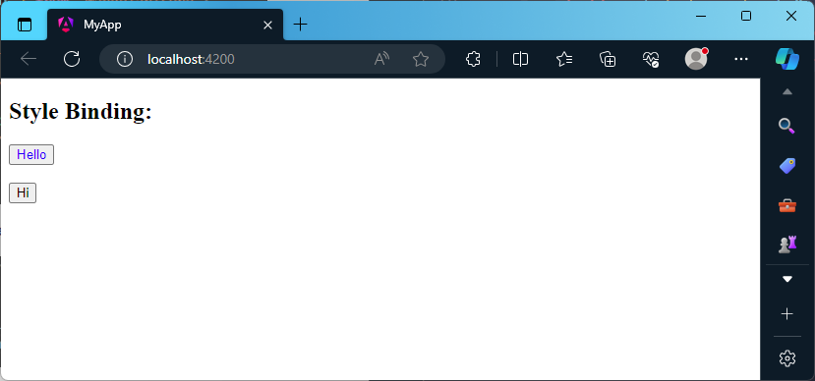

*import* { Component } *from* '@angular/core';

@Component({

  selector: 'app-root',

  templateUrl: './app.component.html',

  styleUrls: ['./app.component.css']

})

*export* class AppComponent {

  title = 'StyleBinding';

  isValid = "";

  isValid1 = '';

}

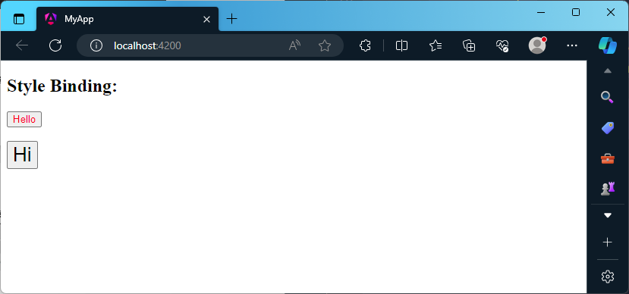

**Event Binding:**

*import* { Component } *from* '@angular/core';

@Component({

  selector: 'app-root',

  templateUrl: './app.component.html',

  styleUrls: ['./app.component.css']

})

*export* class AppComponent {

  onSubmit()

  {

    var un=(document.getElementById("uname") *as* HTMLInputElement).value;

    (document.getElementById("id1") *as* HTMLInputElement).innerHTML="Your name is:"+un;

    var p=(document.getElementById("pwd") *as* HTMLInputElement).value;

    (document.getElementById("id2") *as* HTMLInputElement).innerHTML="Your Password is:"+p;

  }

}

<h2>Event Binding:</h2>

<table>

    <tr>

        <td><label for="uname">Enter User Name:</label>

        <input type="text" size="20px" id="uname" required autocomplete="off" placeholder="Enter your username/id"/><br/><br/></td>

    </tr>

    <tr>

        <td><label for="pwd">Enter Password:</label>

        <input type="password" id="pwd" required placeholder="Enter your password">&nbsp; &nbsp; &nbsp;</td>

    </tr>

    <tr>

        <td><button (click)="onSubmit()">Login</button>&nbsp; &nbsp; &nbsp;</td>

    </tr>

</table>

<div id="id1"></div>

<div id="id2"></div>

